1.0 Scope |  |  |  | 2.0 Resource Required
1.1 Purpose: Stacking and lifting of glass at all the annealed line  1.2 Area of Application: All annealed packing station  1.3 Responsibility: Shift Packing Officer  1.4 Accountability: Section head & Production head |  |  |  | 2.1 Man: Shift Packing Officer  2.2 Machine: Stacker  2.3 Material: Torch, Glass separator, Glass holding clamp, Glass rack
3.0 Terms and Definition |  |  |  | 4.0 Key Performance Requirements
3.1 TPD: Tons per day  3.2 NCM: Non-Conformity Material |  |  |  | 4.1 Quality: Scratch free stacking of good glass on rack with desired quantity  - EHS: No cut injury or ergonomic incident
5.0 Frequency |  |  |  | 6.0 Competency Enhancement
5.1 For each glass produced in annealed line |  |  |  | 6.1 Training on Glass lifting & robot to be given to all shift officers & Contract workers.  6.2 Visual posters are to be used for Do’s & Don’ts & communication.
7.0 Procedure
7.1 Sequence of Operation

7.1.1 Rack & workplace preparation:  - Make the annealed glass rack free from glass chipping.  - Ensure there are no cullet particles on the air table as well as floor area  - Make available scratch separator pad and it should be free from any glass chipping.  - The rack placement should be done as shown in the figure for each SG line  - This figure is showing the rack placement of SG#1  - This is rack placement standard for SG#2  - This is rack placement standard for SG#3 both line  Note: as shown in the figures the marking already done at all annealing line to place the racks at their proper place  Note: This is the picture of actual marking on shopfloor. |  |  |  |  | 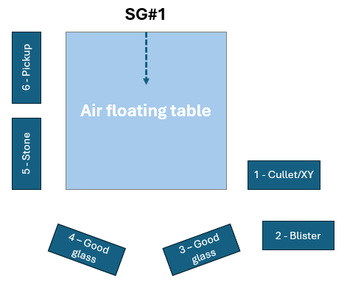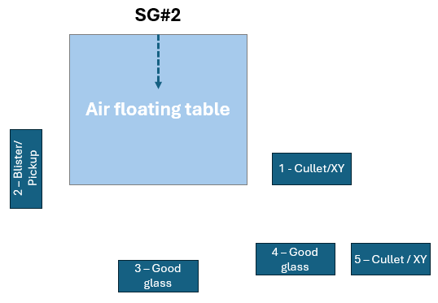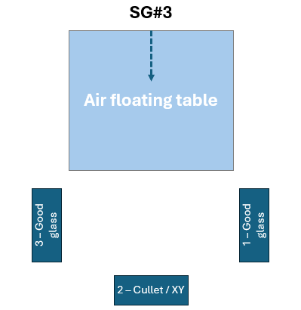  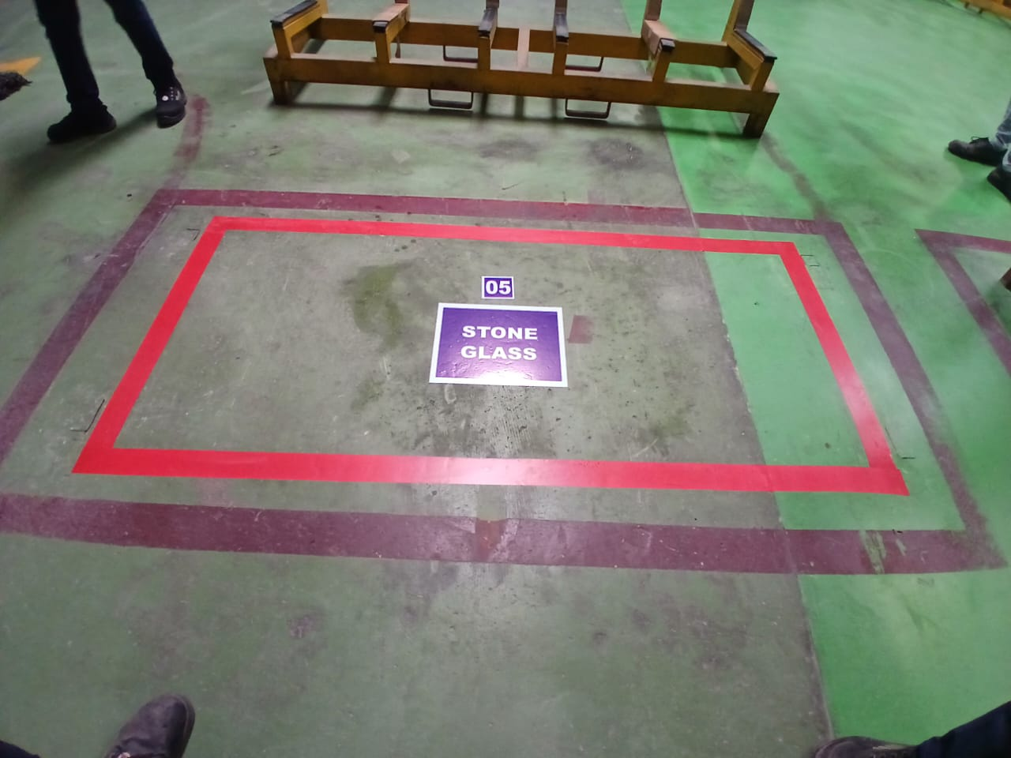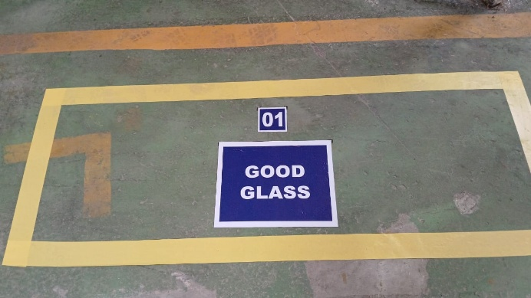
7.1.2 Glass lifting from the conveyor.  - Verify the air cushioning is working on air table.  - Use the Acknowledge push button (Showing in Figure-01) or foot pedal (Showing in Figure-02) to call the glass from roller conveyor to air table.  Note: ensure the glass gently lands on air table to prevent any breakage issue and collision of the glasses.  - Once the glass is on the air cushioning table, inspect it for any visual defects such as scratches, chipping, booth marking or other defects (as shown in Figure-03). |  |  |  |  | 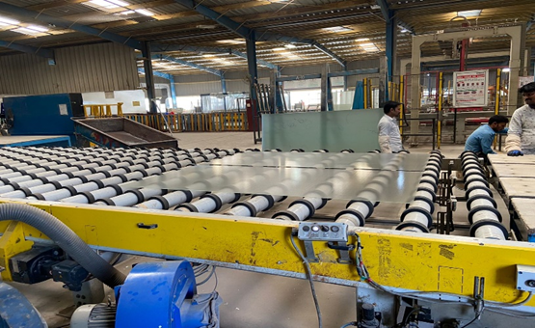  Figure-01  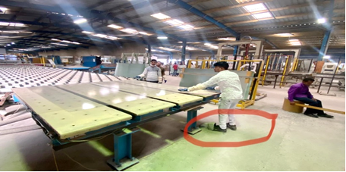  Figure-02  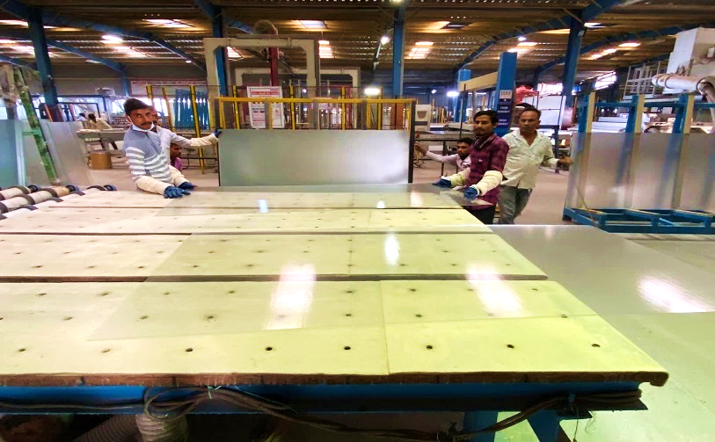  Figure-03
7.1.3 OK Glass stacking on the rack:  - Place the glass separator on the rack (if already glass stored on the rack) as shown in Figure-04  - Lift the glass from both the edges (suitable based on glass size) and place it vertically on the rack just next to the Separator.  - Gently put the glass on the rack fully.  *Ensure the glass should be placed on Good Glass rack only  - Remove the Separator and set the glass sheet properly.  * Ensure there is no horizontal or vertical movement of the glass when stacking it on the pre-stacked pile of glass & carefully align and stack the glass sheets one by one to create a stable pile.  - Continue to follow the steps for lifting and stacking till the rack quantity limit is achieved.  *During the activity, if any glass breakage or other issue is found, please stop the stacking and correct the same and till the time use next rack for the same. |  |  |  |  | 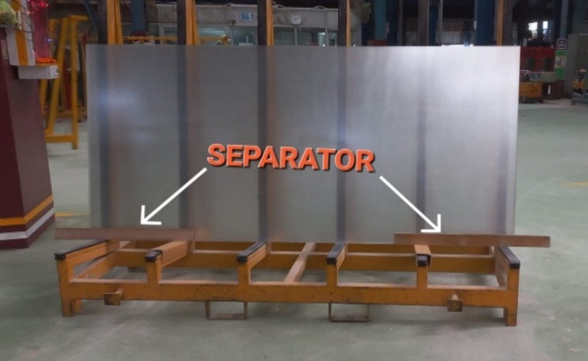  Figure-04  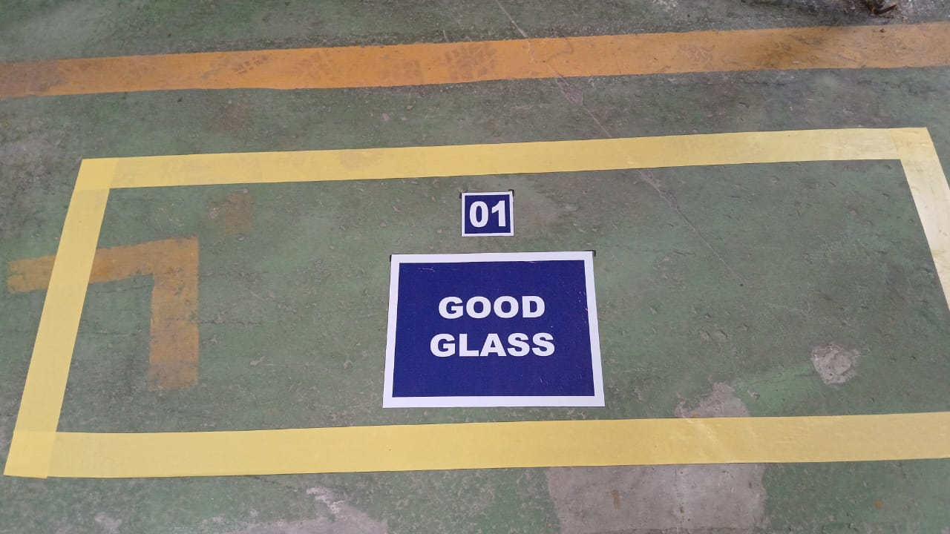
7.1.4 Reject Glass stacking on the rack:  - Lift the glass from both the edges (suitable based on glass size) and place it vertically on the rack just next to the Separator.  - Gently put the glass on the rack fully.  *Rejection should be kept on rejection wise rack only (Stone, blister, pickup and mix)  Note: As it is already rejected glass, there is no need to put/remove separator. Continue to follow the steps for lifting and stacking the rejected glass till the rack quantity limit is achieved. |  |  |  |  | 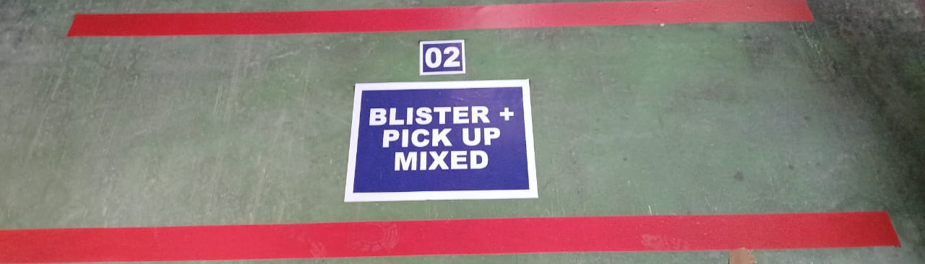
7.1.5 Inspection and Rework:  - Once the OK glass rack is complete, inspect it using torch light from all edges of the glass for any chipping, breakage, marked glass inside the rack (as shown in Figure-05). And if:  - Fount ok, go to direct step 7.1.5 g)  - Found any issue of scratch, marking or breakage follow the steps from 7.1.5 b)  Steps to follow if any issue is found in OK rack:  - Mark the defective glass in the rack with temporary marker.  Note: in case of chipping, immediately inform the Line Cutting Officer  - Place Empty rack and prepare it as mentioned in step 7.1.1  - Transfer the glass from OK rack to empty rack following instruction from step 7.1.3 till the defective glass comes in front.  - Remove the defective glass and cullet it.  - Again, fill the sheets in OK rack and add the sheet to complete the sheet count.  - Print the barcode and insert the barcode in only Rack with OK glasses. |  |  |  |  | 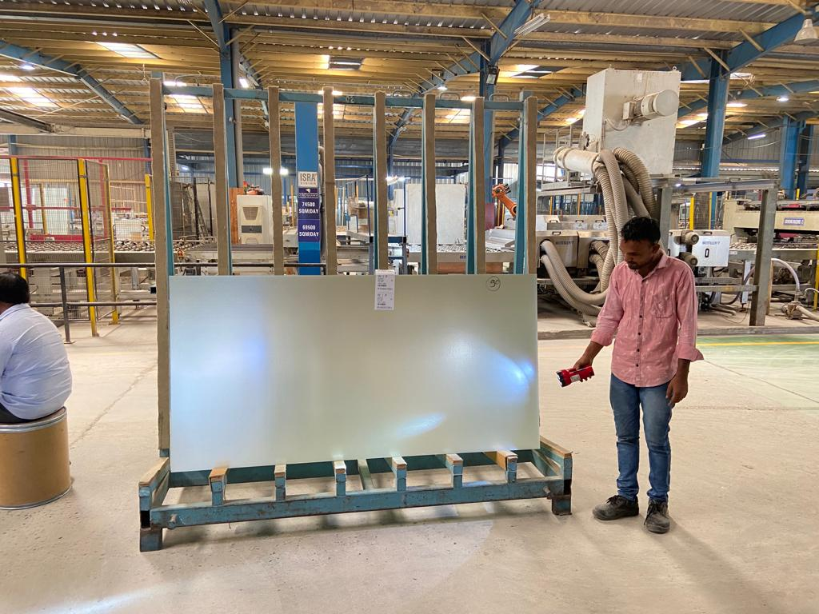  Figure-05
7.1.5 Record:
- OK pieces, rejection pieces and problems need to record in sheet.
7.2 Special Process Requirements
Not applicable
7.3 Prevention & Detection Controls
7.3.1 If any chipping or cutting issue observed continuously, inform the cutting in charge for correction

7.4 Controls Related to EHS
7.4.1 PPE MATRIX
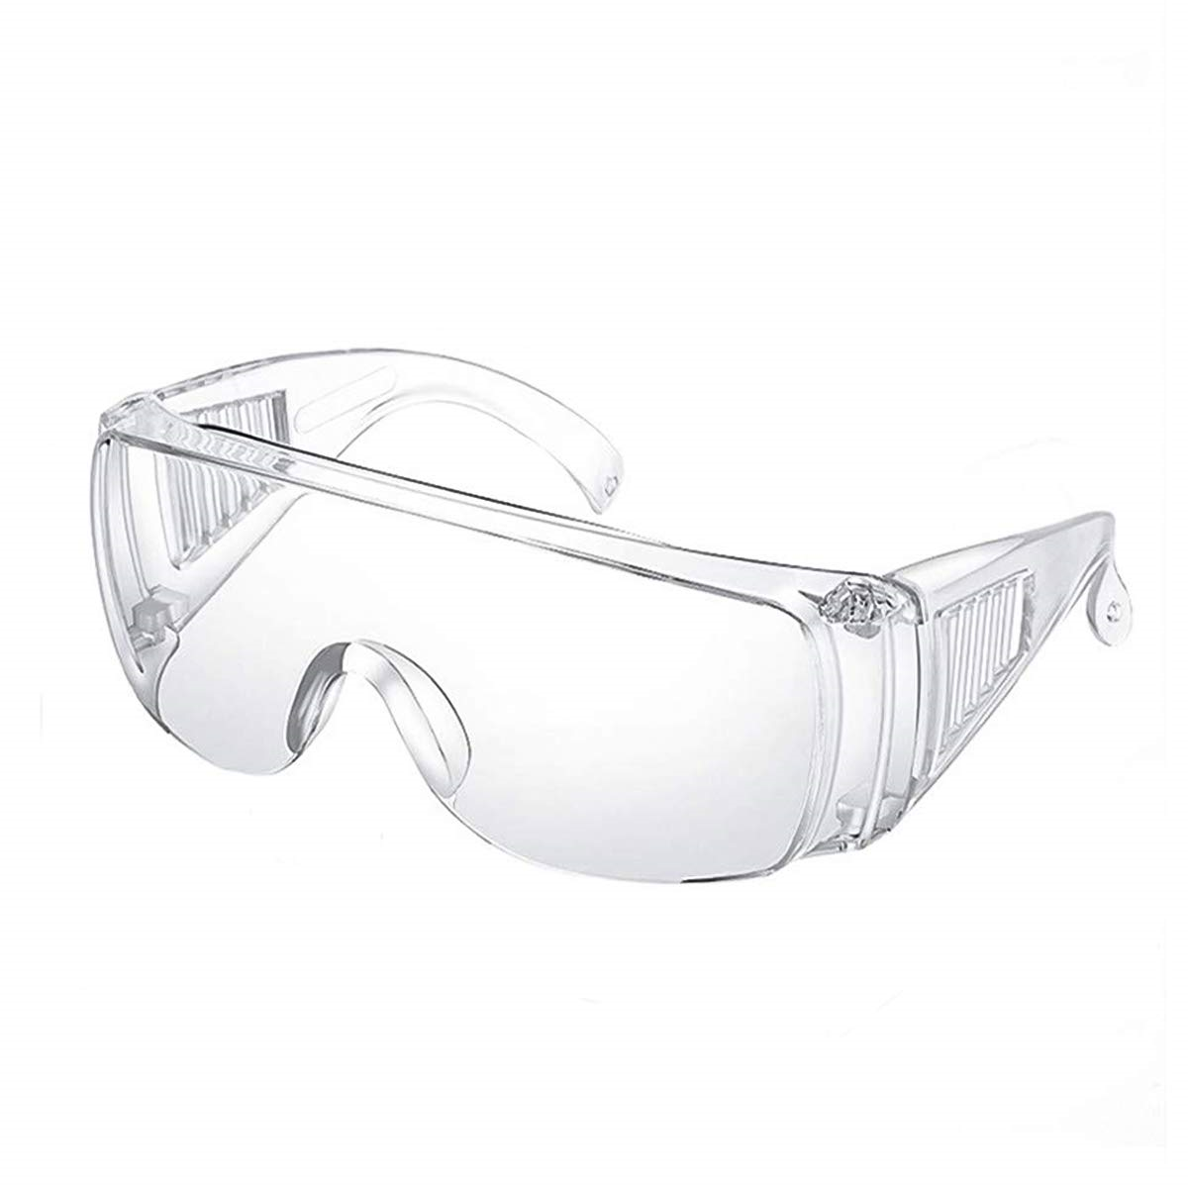 | 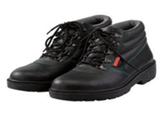 |  |  |  |  |  | 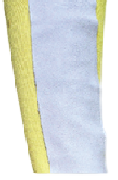
Goggles | Safety shoes |  | Hand Gloves |  |  |  | Arm Guard
7.4.2 All broken glasses need to collect in cullet bin and dispose of it to main crusher
8.0 EHS Compliance Obligations
8.1 Not applicable

9.0 Possible deviation & Impacts |  |  |  |  |  | 10. Proposed actions
9.1 Improper stacking alignment of glass can lead to breakage.  9.2 Defected glass kept with OK glass may lead customer complaint or process loss |  |  |  |  |  | 10.1 Stack the glass on rack with proper alignment.  10.2 Defective glass and OK glass should be kept on identified racks separately
11. Reference documented information
11.1 Daily pull data Annexure-1

12. Revision History
Revision No. | Date | Description of changes
00 | 12.02.2020 | Initial release.
01 | 01.07.2023 | Picture & safety requirement added
02 | 27.10.2025 | Format standardized, revision history added, step correction done.  Rack location layout added.

